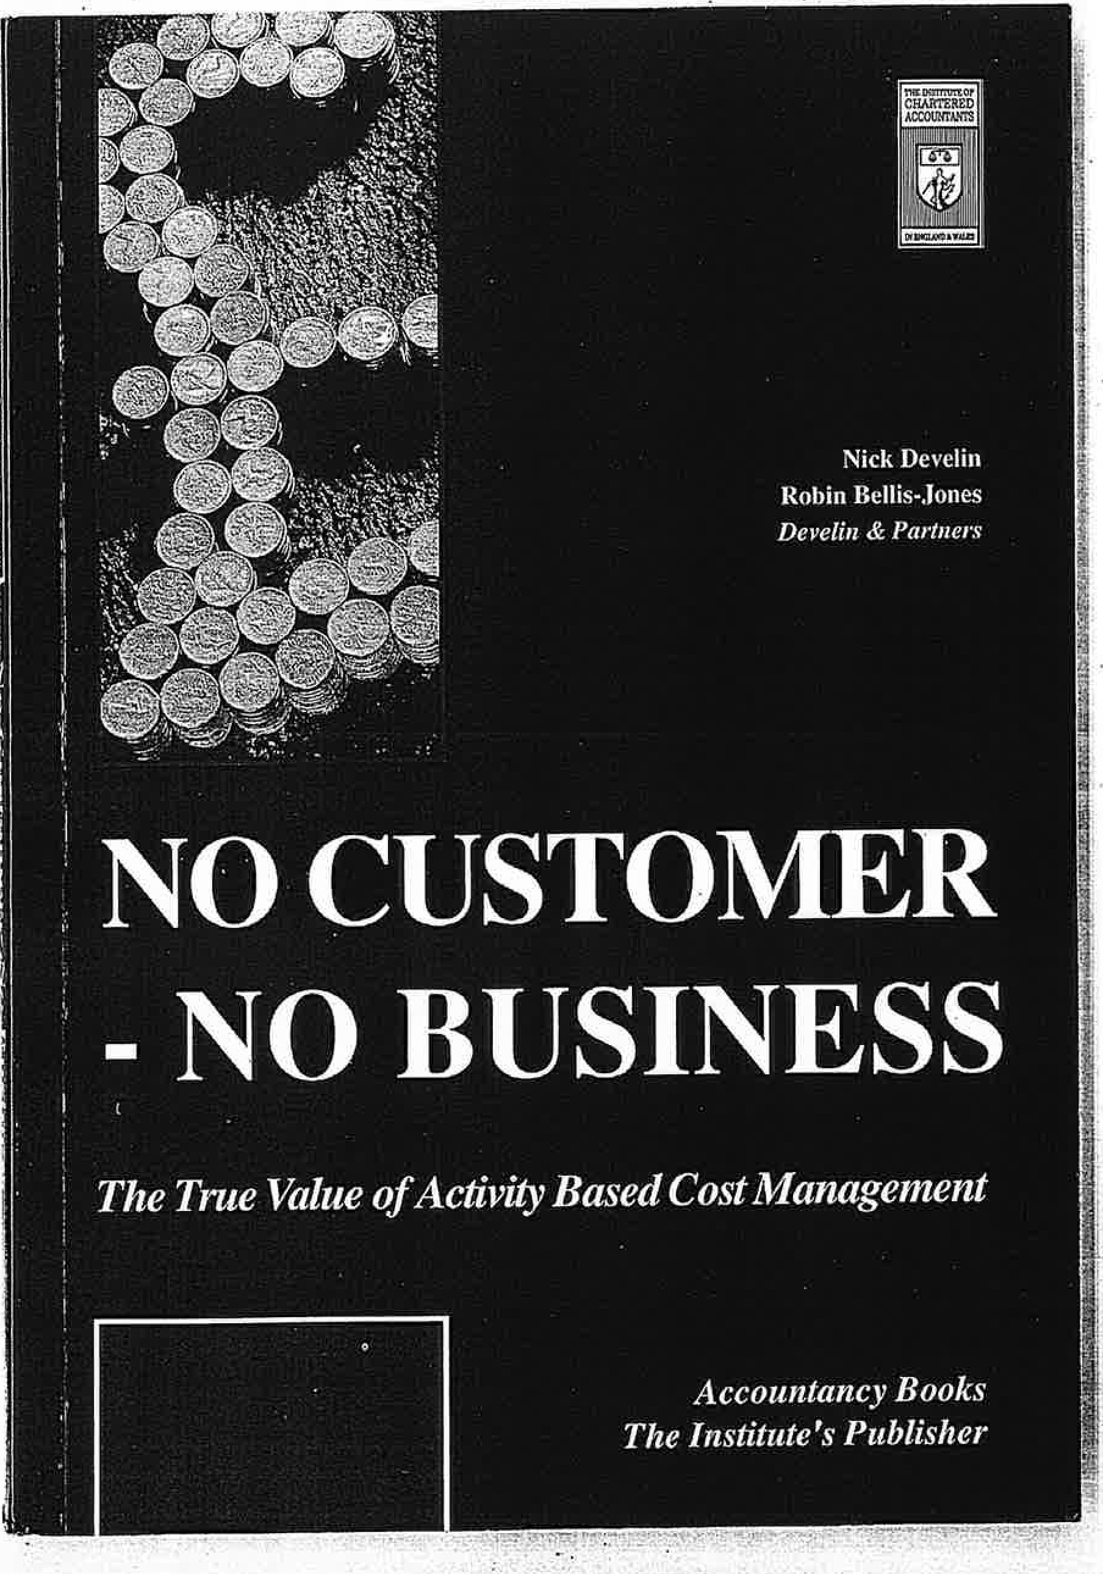

,'

!

j

at managers in any discipline, and is as much about breaking down the functional barriers in organisations, and about values, beliefs and behaviours, as it is about methods and techniques. Robin Bellis-Jones

Nick Develin
CHAPTER 1

Develin & Partners 211 Piccadilly London W1V 9LE
The climate of change

... bump, bump, bump, or1 the back of his head, behind Christopher Robin. It is, as Jar as he knows, the only way to come downstairs, but sometimes he feels that there really is another way, if only he could stop bumping for a moment and think of it.

A. A. Milne
In 1989 a British manufacturer of pumps decided that it was no longer economic to manufacture in the UK Alongside their own products, the company imported, badged and sold a complementary line of pumps manuiactuied in the Far East. The imported product sold for a highly competitive price which gave a good profit margin, and was rapidly gaining market share; the in-house manuiactured pumps had low margins and were losing market share.
Fortunately, the finance director and the sales director were personal friends and extremely bad golfers. During an extended game they discovered that they both shared considerable unease about the decisibn to close the factory, for different reasons.
The information that underpinned the decision was based on standard costs. Manufacturing overheads, and a considei;able proportion of non­ manufacturing overheads, were recovered into product costs on the basis of direct labour hours. The imported pumps required very little direct labour (change the voltage, rebadge, repackage), and therefore attracted little overhead. The sales director instinctively felt that this misrepresented the true cost of the imported product, and furthermore, he believed that it was underpriced in the market.

Apart from the drastic prospect of closing the factory, the finance director was concerned about which non-manuiacturing costs would

1
viii

The climate of change
need to be retained to service both the imported products and the

Change
The climate of change

imported replacement for the in-house product. He askeda recent graduate recruit to conduct a one-week exercise to interview departmental managers with this question: which costs would you
have to keep, and which could be cut?

The result was sufficiently disturbing to delay the final decision, and led to an exercise that used activity based costing asa more rational basis for determining product costs. The in-house manufactured prod­ uct turned out to cost much less than the standard costing system had alleged, and could be profitable at a much lower price. The true cost of the imported product was much higher, but it could coll1ffianda higher
price while still gaining market share.

This story illustrates the extent to which companies depend on stand­ ard costing systems and other management accounting information when making critical decisions - in this case, a strategic decision of great importance. It raises the question: how many such decisions in British industry have been based on such flawed information sys-
tems?
Activity based costing (ABC) acquired prominence in the late 1980s, particularly following publication in 1987 of Johnson and Kaplan's book Relevance Lost: the Rise and Fall of Management Accounting. That book focused primarily on product costing, but as its title implies, the issue is not only costing systems, but management accounting in general. ABC therefore embraces the whole question of management
information.
We use the term activity based cost management (ABCM) to broaden the scope further, first by including the subject of customer profitability, and secondly by recognising the relationship between the theory of ABC and the management style and philosophy through which it is
practised.
The purpose of this book is to critically examine traditional approaches to costing and management accounting, to describe the essential char­ acteristics of activity based systems, and to set these in the broader
context of change management.

2
the struggle to gain competitive advantag in markets that grow more fiercely contested day by day has radically altered the complexion of many bus.iness_es: the direct costs of products and services have been cut, technology and automation have been widely adopted, and devel­ opment and life cycles of products and services shortened.
These changes have caused a major shift in the cost structures of many organisations. In the manufacturing sector, direct labour costs have given way to an increasing 'burden' of overhead costs. Demanding markets and competitive capability have increased both the complexity and scope of companies' products and services in every sector, with quality becoming a critical factor in business success.
Major changes are occurring to the culture with.in which organisations manage themselves. The mnnber of managers who adopt an autocrati.c style is cllininishing, and the concepts ol total quality and business re­ engineering are spreading rapidly.
Amid all this change, cost accounting has largely continued to employ the techniques of the 1950s and 1960s in providing management with the basic information on which key product and investment decisions are made. These techniques recover the costs of overheads using indices such as direct labour or machine 1,ours, which reflect production volume alone. They largely overlook the factors that increasingly drive costs, such as variety, complexity and change.

Competitive Advantage
Rarely do companies fail or lose competitive edge through lack of commitment and hard work from their management and staff. Rather, they fail because they make consistently worse decisions than their competitors. The consequences in human terms are dismal enough, but the consequences .in national terms are nothing less than catastrophic. In Britain we have lost the competitive advantage we once held in industries such as motor cycles, shipbuilding, textiles, electrical goods and many more.
Governments have played their role in Britain's industrial decline, but it is too easy to blame governments for such wholesale industrial

3

failures. One of the key differentiators is management practice, within which management information is a critical element. Good information
- knowledge - is the life-blood of good decisions. We contend that management accounting, as practised today in many British com­ panies, is failing management, often by not providing adequate information for decision making, and sometimes by providing informa­ tion that is actually misleading. Nobody comes to work deliberately to make mistakes. Nobody consciously makes bad decisions. While good information cannot guarantee good decisions, poor information does guarantee poor decisions. In the absence of good information, profit is more a matter of luck than judgement, and is unlikely to be either consistent or sustained.

British companies are threatened by competitors from abroad par­ ticularly from Europe and Japan, who do demonstrate both consistent success and the ability to sustain it.

Management accounts and management information
Activity based costing has been described as a revolution in costing systems. Revolutions make people nervous. There is an implication that the previous order was so flawed that revolution is preferable to steady evolution. Particularly in the case of accounting systems, such an assertion is worth careful examination, and the new approach must be tested for relevance in addressing the problems that companies face.

In recent years, traditional methods of cost' accounting have been criticised both for failing to provide appropriate information and for providing misleading information, with the result that companies:

- do not know whether or not their products or services are profit- able;
- cannot distinguish profitable from unprofitable customers;
- make incorrect make/buy decisions;
- initiate cost-cutting programmes that fail;
- introduce products that are certain to be uncompetitive;

4

- miss important investment opportunities, or make inappropriate ones;

- drive up manufacturing costs;

- design inappropriate organisation structures;
- focus on the short term at the expense of the long term;

- lack the visibility of their operations that they need to manage the business;

- maintain barriers to change.

This isa formidable list of charges. The issue here is management information: in the majority of British companies, the monthly manage­ ment accounts are the only regular information about the business that managers receive. The recurring problem is that management accounts fail sufficiently to re.fleet the complexities of the operating environment. Managers are of course capable of making bad decisions even when they have good information, but this is no argument for providing misleading or irrelevant information. Furthermore, if the system fails to provide relevant information - that is, it omits what is critical or useful,
managers are obliged to rely on intuition.

DrW. Edwards Deming, the quality 'guru', asserted that the most important numbers for any business are the values that attach to happy customers, quality improvements, teamwork, pride in workmanship, and so forth. They are never known, but must be taken into account by management. The greatest danger comes from relying on 'visible fig­ ures' alone to run the business - by which he meant the financial accounts. Most management actounts are a subset of the company's financial accounts, and are expressly designed to be so. This stems from
company failures in the 1930s that led governments to intervene with regulations to ensure accurate balance sheets, which in tum encour­ aged consistency between intemal and external accounts.

The danger :is therefore twofold: first, that management should rely almost exclusively on accounting information to run the business, and second that the information is itself incorrect or misleading for the purpose of making sound operating and strategic decisions.

5

Management trends
David Allen, the Chartered Institute of Management Accountants (CIMA) Industrial Professor at the University of Loughborough, has identified a number of management trends that are being driven by economic and competitive realities as businesses move into the 1990s. These are summarised in Figure 1.

Figure 1 Management trends
From Stability National Tactical Functionalist Centralist Individualism Tangibles Quantity Products Direct costs Analysis Reactive Accounting
Static
To Discontinuity Global Strategic Generalist Devolved Teamwork Intangibles Quality Customers Indirect costs Synthesis Proactive
Financial management
Dynamic
navigate. Intuition, emotion, and even personal experience are not enough: management needs knowledge. In all but the smallest com­
panies, there exists a structural barrier to change, illustrated in Figure 2.

Figure 2 Authority and knowledge
HIGH
)
Authority to change a process
LOW
LOW Detailed knowledge of the process HIGH
--
";"#'
h·,
'-----"

Most organisations will identify readily with these trends, and also recognise them as a turbulent sea through which management must

6
Staff, through experience, have a good knowledge of the activities
- within their own functions, although they normally lack visibility of the cross-functional business processes of which their own activities forma part. Even with insight, they still lack authority to make changes in the activities they undertake - only management can do that.

As an individual rises through the management hierarchy, his or her detailed knowledge declines, while his perspective broadens and his authority to make change increases. Ultimately, only the board have the perspective and authority to change multi-functional processes, but lack the detailed knowledge to do so effectively. Staff become victims of pro­
cesses they Jack the authority to change, while management become victims of their own lack of knowledge.

7

The nature of change
involves all employeesinmakingimpr0vements. Their ideas tend to be small-scale, inexpensive to implement and concern the individual's
Figure 3.
own area of work. The results are nevertheless dramatic, as shown in
Figure 3 The powe,r of continuous improvement: comparison of American and Japanese suggestion schemes
USA
Japan (Private organisations only)
Total number of eligible employees
Total number of suggestions received
Number of suggestio13s per 100 eligfole
Percentage of employees par­ ticipating
Adoption rate
Average award payment per adoption
Average net savings per adoption
Net savings per 100 eligible
8,364,865
1,685,412
1,010,889
52,898,345
13
3,145
9
80
28.0%
$545.68
82.5%
$2.70
$7,663
$43
$26,870
$356,531
The balance of knowledge and authority in an organisation leads to the conclusion that there are three kinds of change: drastic change, con­ tinuous improvement and innovation.

Drastic change
Drastic change is almost invariably driven by an unwelcome commer­ cial imperative - an external factor. Sometimes, this will be something sudden, unforeseeable and outside the control of the organisation, such as political change or a natural disaster that destroys or radically alters a market. More often, it is successful competitor activity or other more progressive change (such as deregulation) that results in declining market share or profitability. In these cases, although the source of the pain is perceived to be external, it usually results from failure to recognise the impending threat and to improve internal competitive­ ness to meet it. (A vivid illustration of the ability of Japanese industry to plan for, and respond to external threat, is that in the five years to 1987, Japan increased its corporate profitability by 30 per cent, and its annual trade surplus rose from US$45 billion to US$100 billion, despite its currency rising between 50 per cent and 100 per cent against all major currencies.)
Drastic change is always imposed by management, top-down. There is little or no need for knowledge of the detail when implementing such change. (Indeed, a cynic might observe that in such circumstances, too much knowledge inhibits flair, and go on to recognise that perhaps our politicians are appointed to ministerial posts n this principle.)

Continuous improvement
The second kind of change is continuous improvement. Most con­ tinuous improvement is bottom-up, based on knowledge, and depends on the existence of a culture in which people are empowered. It is usually incremental - move a filing cabinet, redesign a form, change the sequence of doing things, adapt an existing design, and so forth.
It is easy to trivialise such change, to regard it as unimportant. A powerful illustration of the power of continuous improvement is shown by a study carried out in 1988 comparing American and Jap­ anese suggestion schemes. The Japanese system (known as Kaizen)

8

Innovation

The third kind of change is innovation. Innovation is often radical change, and like continuous improvement, can only flourish ina culture that encourages it. If there is a barrier of mistrust between those

9

who have authority (the management) and those who have knowledge (the staff), such a climate cannot exist.
In the absence of continuous improvement, an organisation will decline, even if this is only relative to the competition. In this case, decline will result in the need for drastic change. Figure 4 plustrates the contrast between an organisation that combines continuous improve­ ment with innovation, and one which is forced to rely on periodic drastic change.
- acquiring knowledge and understanding of those processes;
- planning, which requires the ability to predict.
Ifa manager is u.riinfonned, or is misled by the information he or she
receives, then personal experience, emotion and intuition are all that remain.

The barriers are structural. It is striking that in many organisations, individuals can hold convictions such as putting the customer first,

Figure 4 Different approaches to change
cooperating across functional boundaries, and empowering staf-f
yet

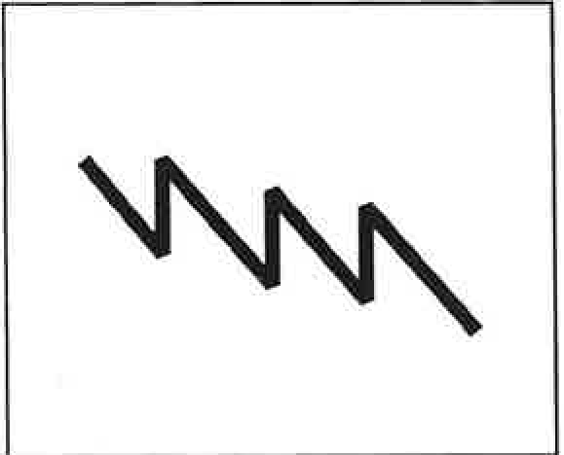
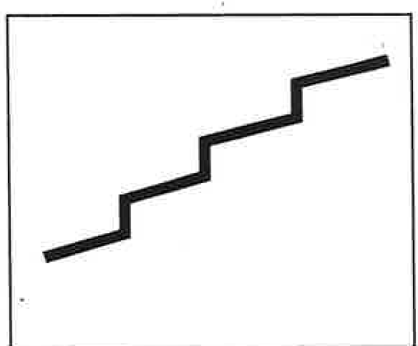
behave ina way that is demonstrably at variance with those beliefs. Why does this happen? Certainly, people do not usually do it consciously. When it happens, the result is invariably frustration and low morale.
Periodic drastic change
Continuous improvement plus innovation
A bank established a centralised unit to provide branches with foreign currency and travellers' cheques. In line with the bank's customer care programme, the unit established methods and processes to pravidea respon­ sive and proactive seroice to branches (anticipating demand tit branch level during the holiday season, managing distribution economically using the bank's bullion runs, and so forth). Inexplicably, demand from the branches fell, and it transpired that branches were buying currenct; and cheques from competitors! The reason was simple: every branch and central unit in the
bank was treated aas profit centre and required to make a 'contribution'. 111e

Drastic change is almost invariably destructive, unless the organisation can fo1low it by introducing the habit of continuous change.
The usefulness of this distinction between different types of change lies in recognising the role of management, and in understanding the barriers to change. The role of management should be to enable the continuous improvement of the processes in which their staff work, by:
  - empowering staff, who have greater detailed knowledge;
  - cooperating across functional boundaries;
  - eliminating fear that inhibits communication;

10
treasury function charged the unit for the currency it 'bought', plusa. margin; and the transport function charged t174 unit for distribution, pluas margin. The unit likewise charged branches, plus a margin. Unsurprisingly, the branches found competit'ors' prices cheaper, and bought from them in
order to ke.ep their own costs down, even though they took longer to supply.
The accounts department spent a lot of time managing all the cross-charges
and trying imsuccessfully to reconcile departmental oonttibutions with overall profit.

Clearly, the result was in the best interests of neither the bank nor its customers. In this case, departmental 'contribution to profit' was the dominant driver of behaviour. Branch managers knew that whatever management sai.d about the importance of customer service, their own faingdureth. eir branch's performance would be judged by the contribution
The point of this story is that nobody perceived any inconsistency between using contribution as a measure of performance, and exhorta­ tion to improve cu tomer service. The branches simply regarded the

11

currency unit's high prices as a typical example of head office incompe­ tence. The currency unit saw branches as a law unto themselves. Both believed in customer service, but their behaviour contradicted that belief, and the resulting frustration was easily blamed on others.
\
With few exceptions, organisations are functional hierarchies. Cost centres reflect the organisation, because it is easy and convenient to
This statement is interesting for what it omits. It contains no mention of strategy, no mention of outputs, no mention of processes, no mention of throughput volumes, no mention of cause and effect, and no mention of the customer. In fact, it is not very useful at alJ. We shall return to this
example in the next chapter.

account for costs on a functional basis, and to replicate the financial chart of accounts at departmental level. Figure 5 shows a typical budget statement for a purchasing department.

Figure 5 Typical departmental budget statement - purchasing depart­
Effective management of change is about management of
functional business processes.

The need
cross­

ment, engineering company
Description
£000s
Salaries
Associated staff costs

Total staff costs
665
113
--
778
Travel and entertainment Staff restaurant Telephone
,1 Stationery Premises - rent
- rates
130
18
14
9
65
13
Total non-staff costs
--
361
TOTAL
1,139
--
Equipment - maintenance | 17
- depreciation | 7
Utilities | 11
Insurance | 5
Management fee | 45
Central computer charge | 27

12
Good management information must therefore describe and monitor the performance of business processes. Since business processes consist
ofa series of linked activities that deliver products and services to customers, management information must:

    - reflect the customer's perspective;
    - provide visibility of business processes;
    - explain or demonstrate cause and effect;
    - identify the profitability of both products and customers;
      - embody strategy;
      - reflect reality;
      - be predictive;
- be in the language of management.

Activity based cost management is aimed specifically at this need. Its objective is to provide the information needed to improve business processes, and then sustain the improvement, first by enabling manage­
ment to focus on'do.ing the right things', and secondly by providing an approach to 'doing them right'.

h, the next pter, we examine more closely the strengths and weak­
nesses of conventional approaches to management information in relation to this requirement.

13

